Pseudotime Analysis Results of Four Genes with Temporal Expression Changes

Pseudotime Trajectory of CD38 in Plasma Cells
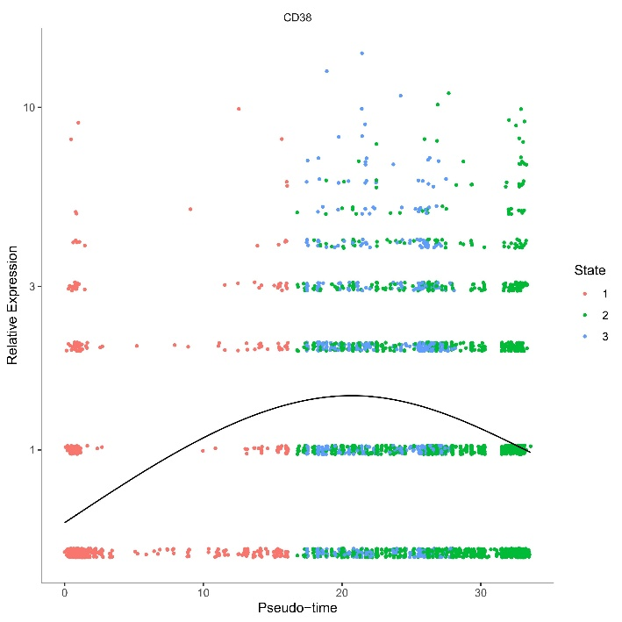
Pseudotime Trajectory of FCHSD2 in Plasma Cells
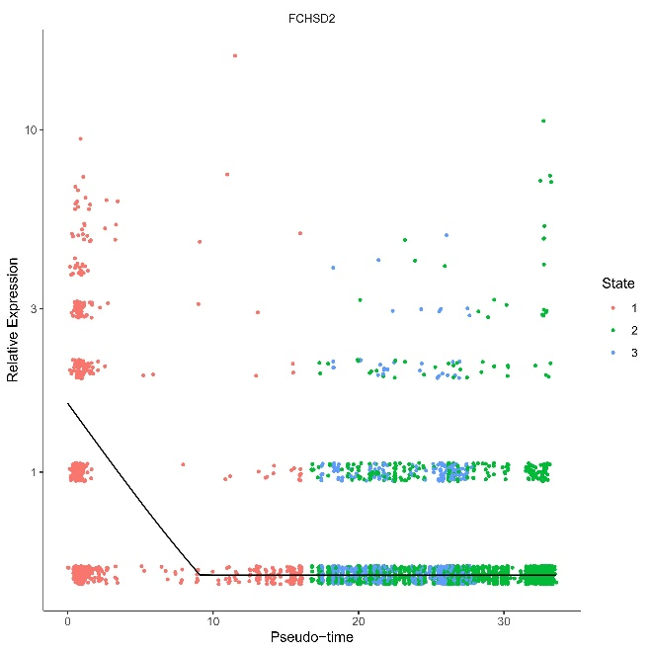

Pseudotime Trajectory of CD53 in Myeloid Cells
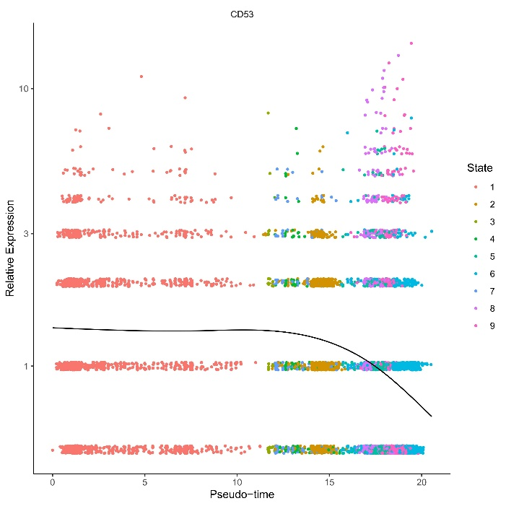
Pseudotime Trajectory of SPOCK2 in CD4+ T Cells
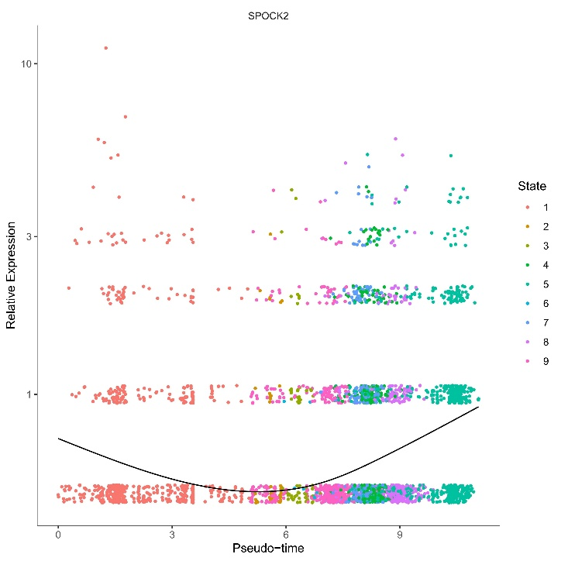

Pseudotime Differentiation and Trajectory of Plasma Cells
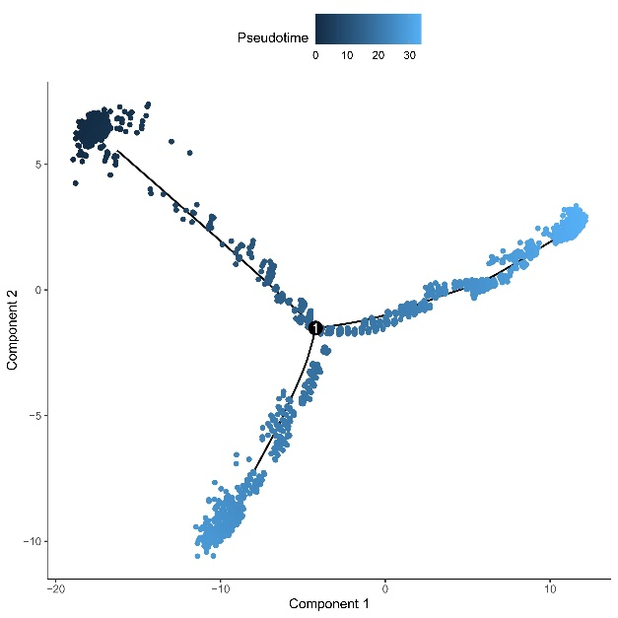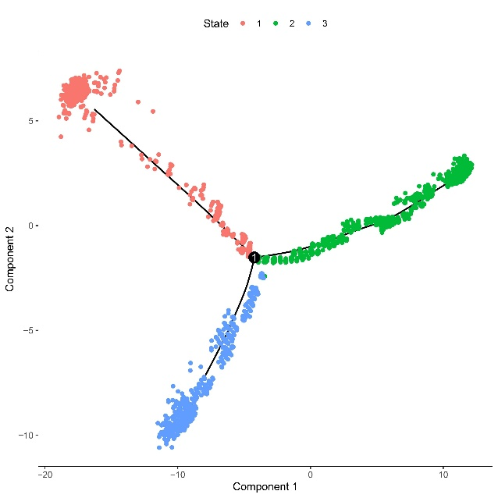
Pseudotime Differentiation and Trajectory of Myeloid Cells
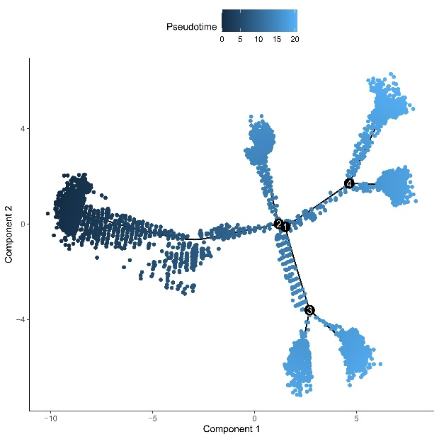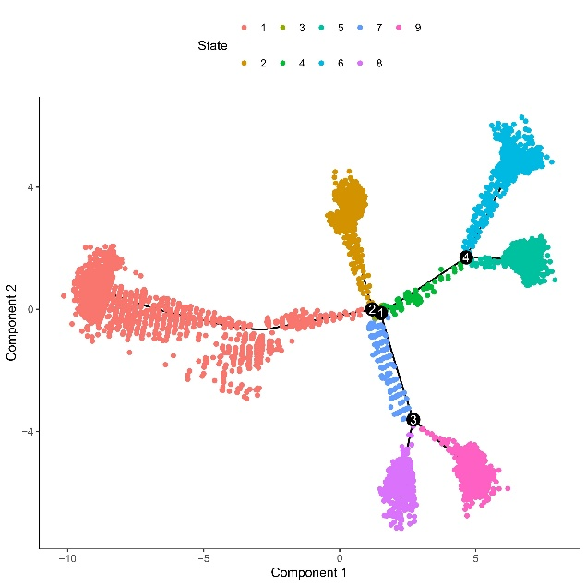
Pseudotime Differentiation and Trajectory of CD4+ T Cells
